**OUTREACH SCHOOLS EXAMINATION BOARD**

 **BEGINNING OF TERM III EXAMINATION 2024**

**PRIMARY THREE**

**LITERACY 1B**

**A**

**B**

**For Examiner’s**

**use only**

**TOTAL**

***Time Allowed: 2hours 15 minutes***

**Name: ______________________________________________**

**School: _____________________________________________**

**Class: ___________________________________________**

**SECTION A (40 marks)**

**Section A.**

1) Name **one** plant found in your school compound.

_______________________________________________________________________

2) How can you keep your school uniform clean**?**

_______________________________________________________________________  
3) Write down **one** importance of trees in a home.

_______________________________________________________________________  
4) Identify **one** item made by a potter.

_______________________________________________________________________  
5) What is the use of a compass on the map?

_______________________________________________________________________

6) How is too much rainfall dangerous to people?

_______________________________________________________________________  
7) Give **one** importance of doctors and nurses in our community.

_______________________________________________________________________  
8) Name **one** symbol of a school found on your school uniform.

_______________________________________________________________________  
9) What are physical features**?**

_______________________________________________________________________  
10) Identify **one** lake found in Kampala district.

_______________________________________________________________________  
11) Draw and name **one** item made by a carpenter.

12)How can pupils help their teachers in class

_______________________________________________________________________  
13)State **one** way children misbehave to their friends.

_______________________________________________________________________  
14) What is a home?

_______________________________________________________________________  
15)Name **one** important room found in house.

_______________________________________________________________________

16) Of what importance was a dog to early man**?**

_______________________________________________________________________  
17) Write the motto of your school.

_______________________________________________________________________  
18) Who heads the Local Council committee**?**

_______________________________________________________________________  
19) State any one example of a wild animal.

___________________________________________________________________________  
20) Name any one cash crop found in our community.

__________________________________________________________________________

21) What are food crops?

_______________________________________________________________________  
22) Where should wrong doers be reported?

_______________________________________________________________________

23) How are children mistreated in homes?

_______________________________________________________________________

24) Mention any **one** right of children in Uganda.

_______________________________________________________________________

25) Why do people keep domestic birds?

_______________________________________________________________________

26) What are flowering plants**?**

_______________________________________________________________________

27) Draw and name the road sign which helps school children to cross

the road safely.

28)Identify one mean of air transport.

_______________________________________________________________________

29) Which tribe speaks Lugisu**?**  
___________________________________________________________________________

30) Name any one example of a social service.  
__________________________________________________________________________

31) What is the main economic activity carried out on lakes and rivers**?**

__________________________________________________________________________

32) Name the language spoken by the Baganda.

___________________________________________________________________________

33) What is the capital city of Uganda?

__________________________________________________________________________

34) Draw the map symbol of a bridge.

35) State **one** use of banks to people.

_______________________________________________________________________

36) Why was Walumbe called a cruel person?

__________________________________________________________________

37) Which word means the sending and receiving of messages?

___________________________________________________________________

38) How does the Police keep law and order?

____________________________________________________________________

39) What is the main source of water used in Kampala?

_____________________________________________________________________

40) How important is a zebra crossing to pedestrians?

_____________________________________________________________________

**Section B.**

41) How are the following people useful in a family**?**

i) Mother __________________________________________________________________

ii) Father __________________________________________________________________

b) Name **one** type of family.

___________________________________________________________________________

c) Mention **one** problem faced by families.

___________________________________________________________________________

42) What are food crops**?**

___________________________________________________________________________

b) Name any **two** food crops grown in your area.

i) _________________________________________________________________________  
ii)_________________________________________________________________________

c) How can a P.3 child care for crops in the school garden**?**

______________________________________________________________________

43) Study the weather chart below and answer the questions that follow.

|  |  |
| --- | --- |
| MONDAY | https://encrypted-tbn3.gstatic.com/images?q=tbn:ANd9GcSpoWpwb-eqqPRCRUsOMsISBCh6cMOiElbbKI_79KmEcR5N6-99https://encrypted-tbn3.gstatic.com/images?q=tbn:ANd9GcSpoWpwb-eqqPRCRUsOMsISBCh6cMOiElbbKI_79KmEcR5N6-99https://encrypted-tbn3.gstatic.com/images?q=tbn:ANd9GcSpoWpwb-eqqPRCRUsOMsISBCh6cMOiElbbKI_79KmEcR5N6-99 |
| TUESDAY |  |
| WEDNESDAY |  |
| THURSDAY |  |
| FRIDAY |  |
| SATURDAY |  |
| SUNDAY ­ |  |

**KEY**

 cloudy

rainy

sunny

windy

1. What was the weather on Saturday **?**

_______**_______________________________________________________________**

b) Name any **two** rainy days in the week.

i)___________________________________________________________________  
ii)___________________________________________________________________

c) How is the weather on Monday dangerous to people**?**

________________________________________________________________________

44) What are domestic animals?

b) Draw and name any three examples of domestic animals.

|  |  |  |
| --- | --- | --- |
|  |  |  |
|  |  |  |

45) Study the compass rose below and answer the questions that follow.

**X**

A

**East**

**South**

a)Name the points .

i) **X _____________________________i**i) **A__________________________________**

b) Of what use is a compass to a tourist**?**

______________________________________________________________________

c)Name one place where a compass can be found .

______________________________________________________________________

46) Who is a leader**?**

______________________________________________________________________

b) Give **two** qualities of good leader.

i)_____________________________________________________________________

ii)______________________________________________________________________

c)Identify **one** example of a leader in a class.

______________________________________________________________________

47) Match the following correctly:-

**A B**

a)Plateau controls soil erosion

b) Terracing kills animals in game parks.

c) poachers is a table land

d) Museum keeps things of long ago

a)Plateau____________________________________________________________

b) Terracing ________________________________________________________  
c) Poachers________________________________________________________

d) Museum________________________________________________________

48) Name the materials used for making these things.

i) bricks ____________________________________________________________

ii) clothes__________________________________________________________  
b) State **two** domestic uses of water.

i)__________________________________________________________________

ii)__________________________________________________________________

49a) What is a community **?**

___________________________________________________________________

­­­­­­­­­­­­­­­­___________________________________________________________________

b)Mention **one example of people found in the community.**

­­­­­­­­­­­­­­­­___________________________________________________________________

b) Draw and name any two needs of a community.

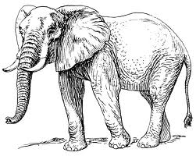**50) Study the pictures below and answer questions that follow.**

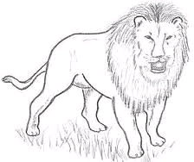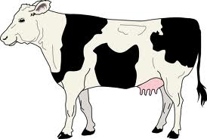

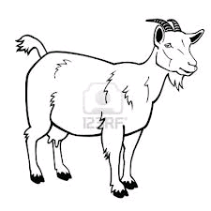

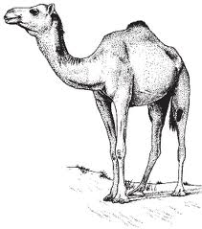

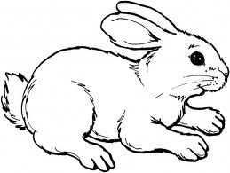**C**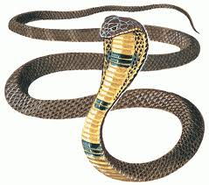

a) Identify **one** domestic any one wild animal from the picture above.

i) Domestic ____________________________________________________________

ii) Wild_________________________________________________________________

b)How is animal **“ c”** dangerous to people.

______________________________________________________________________

c) State **one** way of caring for the animals above.

______________________________________________________________________

51)a) Name any two animals we use for transport.

i) ______________________________ ii) ________________________

b) Give two causes of road transport.

i) __________________________________________________________

ii) __________________________________________________________

**52)Write “Yes” or “No” at the end of each sentence**

(a) Nyamata was Nyinamwiru’s beautiful daughter. _________________

(b)Mundu and Sera came from heaven. ____________________

(c)Kayikuzi was Nambi’s brother. _________________________

(d)Isaza was the king of Hell. _________________________

**53)Fill in the correct word to complete the table.**

|  |  |
| --- | --- |
| **Building material** | **Source of building material** |
| E.g. stones | Quarry |
| Clay |  |
|  | Forest |
| Grass |  |
|  | Tap |

54)(a)Mention one way of promoting security in a school.

_________________________________________________________________

(b)State tow ways the police maintains law and order in a community.

(i) ____________________________________________________________

(ii) ____________________________________________________________

(c)Give one way used to punish people who cause insecurity in a community.

_________________________________________________________________

55)a) In the lists below, circle only things made from leather.

i) pens ii) flask iii) bags

carpets cups spoons

cupboards shoes food

belts curtains tables

(b)Name one animal which gives us wool.

_________________________________________________________________

**Good Luck**